Assignment 3 CIS 320-02

Nickalas Taylor

Use Cases and Descriptions

**ID: 4**

Title: Create Order

Primary Actor: Customer

Risk level: High

Risk: inefficiently collecting data may lead to incorrect order or order fulfillment

Trace Matrix: This can be traced to a functional requirement of the customer creating an order for Karoline.

**ID: 5**

Title: Modify Order

Primary Actor: Karoline

Risk Level: Low

Risk: modifying the order may lead to problems with order fulfillment

Trace Matrix: This can be traced to a functional requirement of Karoline editing a customer’s order.

**ID: 6**

Title: Delete Order

Primary Actor: Customer or Karoline

Risk Level: Low

Risk: accidently deleting an order or deleting the incorrect order

Trace Matrix: This can be traced to a functional requirement of Karoline or the customer deleting an order.

**ID: 7**

Title: View Previous Orders

Primary Actor: Karoline

Risk level: low

Risk: viewing previous order data presents minimal risk

Trace Matrix: This can be traced to a functional requirement of Karoline viewing previous customer orders.

**ID: 8**

Title: Fulfill Order

Primary Actor: Karoline

Risk level: High

Risk: order fulfillment is critical to day to day business as well as tracking of the information

Trace Matrix: This can be traced to a functional requirement of Karoline fulfilling an order for a customer.

**ID: 11**

Title: Ship Order

Primary Actor: Karoline

Risk level: High

Risk: Properly shipping an order and tracking and logging this information is critical to SKC business and data

Trace Matrix: This can be traced to a functional requirement of Karoline herself or contract to another party shipping an order to a customer.

**ID: 40**

Title: View business information

Primary Actor: Customer or Karoline

Risk level: low

Risk: SKC will want to accurately display information about its business

Trace Matrix: This can be traced to a functional requirement of the customer and Karoline viewing any posted business information on the website.

**ID: 41**

Title: Edit business information

Primary Actor: Karoline

Risk level: low

Risk: SKC will want to accurately edit information about its business

Trace Matrix: This can be traced to a functional requirement of allowing Karoline to edit any existing posted business information on the website.

**ID: 42**

Title: Delete business information

Primary Actor: Karoline

Risk level: Low

Risk: SKC will want to accurately delete information about its business

Trace Matrix: This can be traced to a functional requirement of Karoline needing to be able to Add, Update, and Delete Business Information.

Use Case Diagrams

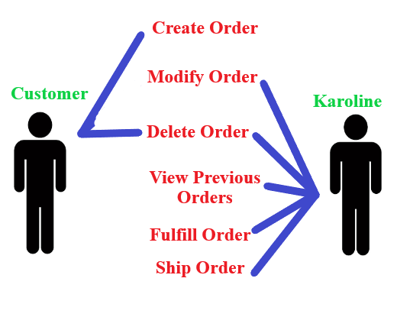

The above diagram illustrates the interactions between a customer and Karoline when engaging in multiple use cases involving a customer order. It is to be concluded that the customer may create and delete their own order and any modifications must be done by contacting Karoline. Karoline may modify, delete, fulfill, and ship an order as well as view *any* previous orders.

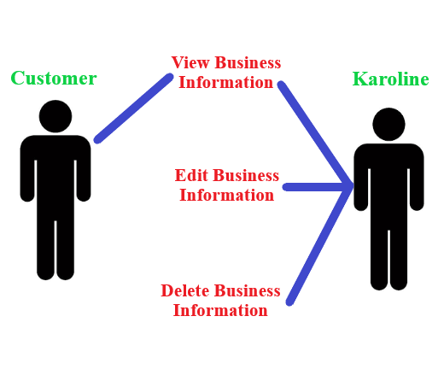

The above diagram illustrates the interactions between a customer and Karoline when engaging in multiple use cases involving business information on the website. It is to be concluded that any customer and/or Karoline may view existing business information, but only Karoline can edit or delete existing business information.

Prototypes

Home Page



Account Form

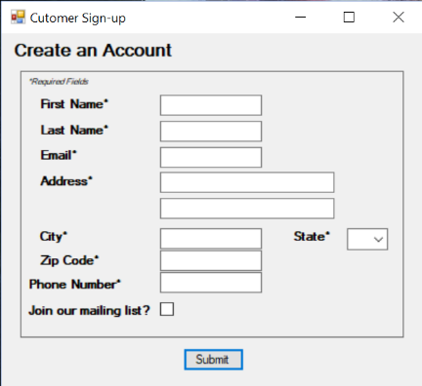

Payment Form

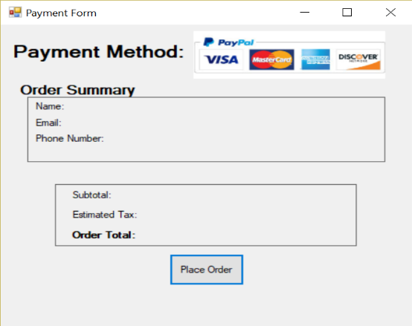

Order Form

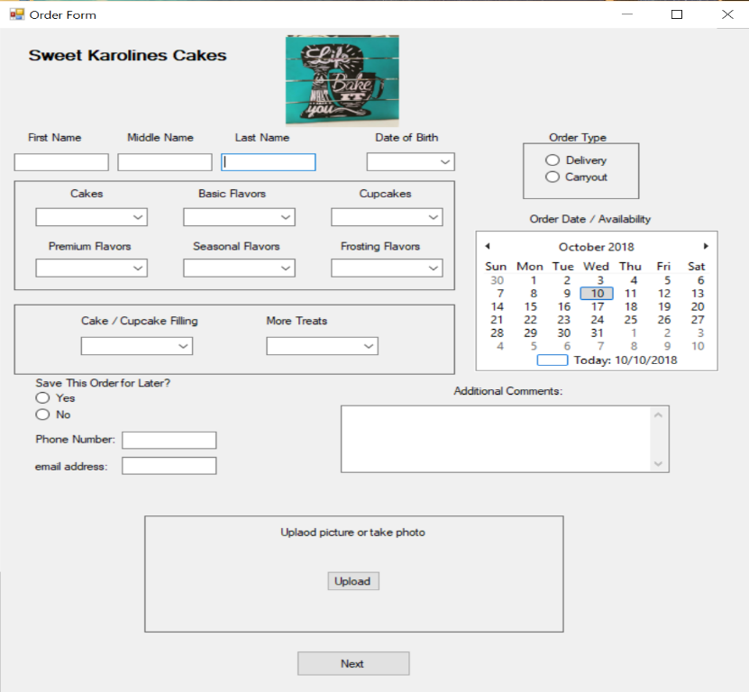

Contact Form

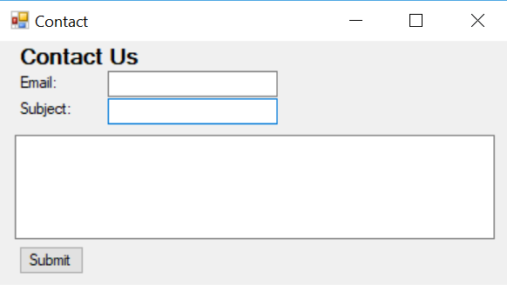

Class Diagram

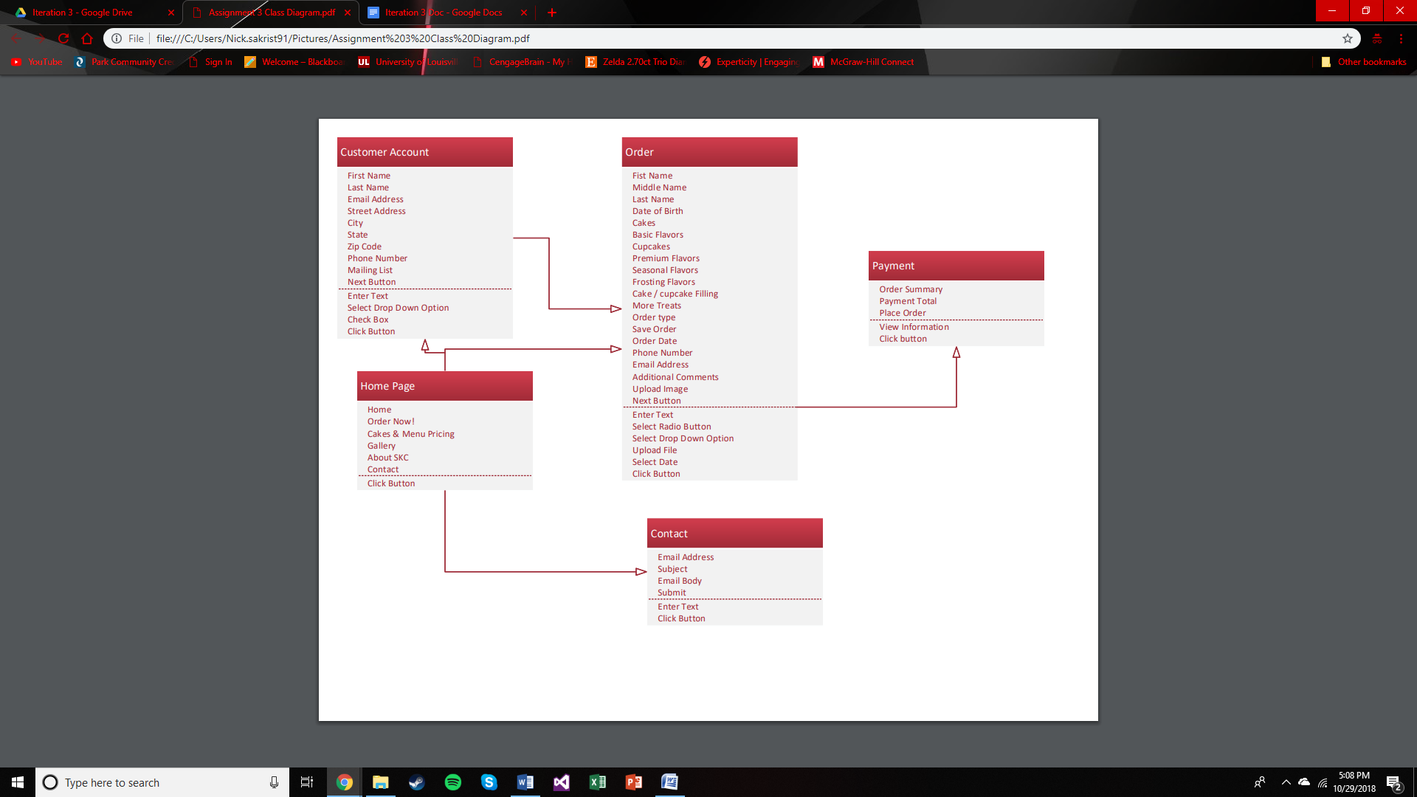

The above diagram depicts the multiple classes (with their attributes and methods) involved in the system, they are: Home Page, Customer Account, Order, Payment, and Contact. There are arrows connecting different classes, if an arrow can be traced from one class to another in a single direction, it is to be assumed that the class in which the arrow is connecting to is dependent on the class of which the arrow is protruding from. For clarification, the Customer Account class has one arrow coming from the Home Page class, indicating that one cannot reach the account form without first going through the home page of the website.

Sequence Diagrams  
